Note: the digital archives of Ethos: A Digital Review of the Arts, Humanities and Ethics, are no longer online. This article was originally published on June 30th, 2014.

No One Is Coming
Ritual and repetition in America, Israel, and Palestine

David M. Faris

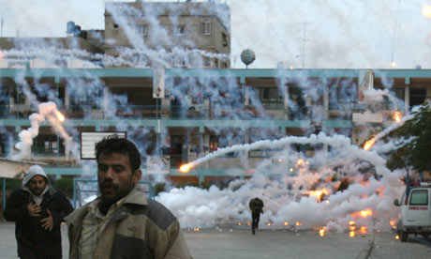
On the set of season 66, episode 2 of Israel-Palestine

There have been so many episodes of the Israeli-Palestinian conflict that the whole sordid mess could be sold to basic cable for immediate syndication. There would be programming enough to last to the end of days and possibly beyond. On this week’s episode: The Israeli military is pummeling Gaza. The so-called “peace process” has fallen apart again. Hamas is lobbing volleys of worthless rockets into Israel. Families are grieving the gruesome and pointless deaths of innocents. In terms of who is doing the dying and the grieving, Palestinians are being extinguished at a ratio of about 100 for every Israeli. If that weren’t bad enough, we are no closer to a political settlement than we were 21 years ago when the Oslo Accords were signed on the White House lawn. The thing about political settlements – they require political settlers, and Israel only has the colonial variety in stock.

So let us re-enact the rituals, all of us who are granted Permanent Non-Voting Observer Status to a conflict that we can watch safely from a distance, those of us who will sleep soundly tonight in houses that we can safely presume will still be there in the morning, on beds that we can say with confidence will not explode with American-made munitions. Let us wring our hands. Let us march for something. Let us call for justice. Let us say critical things about Hamas so that we give ourselves the moral standing to say critical things about Israel. Let us argue about whether criticizing Israeli policy is anti-Semitic. Let us delete friends who say the wrong things on Facebook. Let us talk about how this is the last chance for a two-state solution. Let us talk about being “pushed into the sea” without talking about which group of people is currently at the most risk of getting wet. Let us call this distinctly modern and political conflict “timeless.” Let us continue to call this a war even though a war requires a suitably equipped adversary, or at the very least someone with a gun rather than a pile of rocks culled from the rubble of one’s society. Let us pay the Palestinians to rebuild things we will later pay the Israelis to destroy. Let us use the word “tragedy” instead of the word “crime.” Let us talk about negotiations even though there has never once been a real negotiation between the powerful and the powerless. Let us read and nod along with Nicholas Kristoff columns calling for the Palestinian non-violent resistance movement that has actually existed for longer than Nicholas Kristoff has been writing New York Times columns. Let us hope that it all stops soon so that we can deploy these rituals in repeat for the next invasion of Gaza, tentatively scheduled for mid-2016.

The most cherished ritual in American popular discourse about Israel-Palestine is re-enacting the mythology of symmetry. The next time you watch American news coverage of this conflict, play a game called “Both Sides Bingo.” As in, both sides are responsible. Both sides are engaging in violence. Both sides are suffering. A majority of both sides wants peace. Civilians on both sides are cowering in terror. It’s easy to do, because usually there are reporters in both Gaza and Israel. The image itself suggests two roughly equal entities, two teams aligned across a pitch, with either squad equally likely to prevail. There are, after all, two names of two conceivable juridical entities. But this is a fundamental misappraisal. There are no “sides” in the Israeli-Palestinian conflict. Rather than sides, there is Israeli power, and there is everything else.

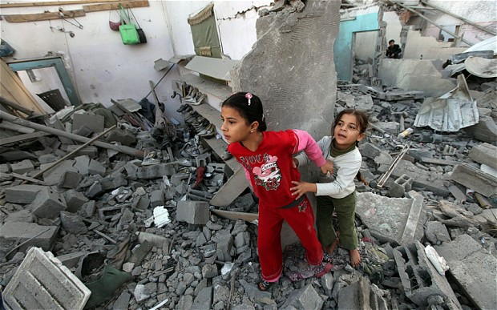
“Both sides”

The Israelis possess one of the world’s most sophisticated and capable militaries, underwritten by the greatest geopolitical power since the Roman Empire. They possess a state, statehood, a seat at the United Nations, a national budget, a functioning political system, an electrical grid, the power to do more or less whatever they please to the Palestinians short of truly mass murder, and the ability not just to defy international law but to effectively rewrite it. And what have the Palestinians? Let us not overestimate what that “everything else” actually adds up to – (1) a ragtag militia with an ineffective arsenal of mostly useless rockets and the ability to occasionally murder someone, (2) some measure of sympathy from countries that are unable or unwilling to do anything with it, (3) a civilian infrastructure that where it still exists would collapse overnight without aid, (4) another powerless non-government in the West Bank, and (5) millions of miserable, stateless and hopeless citizens of a ‘country’ that does not yet and may never actually exist. Add the one, carry the two, divide by seven, and it all adds up to nothing but continued subjugation.

In other words, this is not a coin. It is, on the contrary, a rather one-sided tale of one people becoming progressively more powerful at the expense of another and then either failing to recognize the moral responsibility that this power entails, or failing to act on it. It would be customary here to level some criticism at the Hamas leadership, to unearth that stale cliché about how the Palestinians “never miss an opportunity to miss an opportunity” when it seems much more apt to say that the Israelis never miss an opportunity to punish every single person living in Palestine. So yes, here it goes – the Hamas leadership is doing a really lousy job of governing the powerless people of a tiny strip of blockaded and occupied territory during a time in which the occupying power has not granted them more than 30 seconds at a time to actually govern anything. They should not launch rockets. Q.E.D.

Here are some truths, some of them actually timeless, that our rituals obscure: that collectively punishing entire populations for the actions of a tiny minority is a war crime; that the historical injustice perpetrated against the Palestinian people has been compounded over time rather than made whole; that for something to qualify as a process it must actually lead to something; that when human beings use their power over other human beings to exploit them, confiscate their land and water, and build a wall to imprison them indefinitely, the inevitable result is violence (and yes that was as true in South Africa as it is in Palestine); that the United States has the power to change this and never will unless forced by its own citizens to do so; that Israeli policy is built on the criminal and moral delusion that Palestinians will eventually accept that they are, in the notorious words of Daniel Pipes, “a defeated people” and that once having looked in the mirror and recognized their essential defeated-ness, they will then come crawling to Tel Aviv to accept whatever terms are offered; that the only way to rescue the Palestinians is to build an international boycott movement that is still in its early stages and will always hampered by the policies of the United States.

As for that rescue of the Palestinians, I’m always reminded of a scene between Isabella Rosselini and Stanley Tucci in Big Night. In this overlooked classic from the 1990s, Stanley Tucci’s restaurant owner is duped by a commercial and romantic rival, Pascal, into throwing a giant, business-destroying party for the jazz musician Louis Prima. When it becomes clear that Prima isn’t coming after all, that the restaurant is lost and that Tucci’s ‘friend’ has stabbed him in the back, Rosselini –whose husband faked Louis Prima’s visit – pulls his brother aside and delivers the bad news:

“No one is coming. No one was ever coming.”

