Note: The archives of Ethos: A Digital Review of Arts, Humanities and Ethics, is no longer available online. This article was originally published on June 13th, 2015.

Why We Can’t Have Nice Things
Amtrak and the Deterioration of American Infrastructure
David Faris

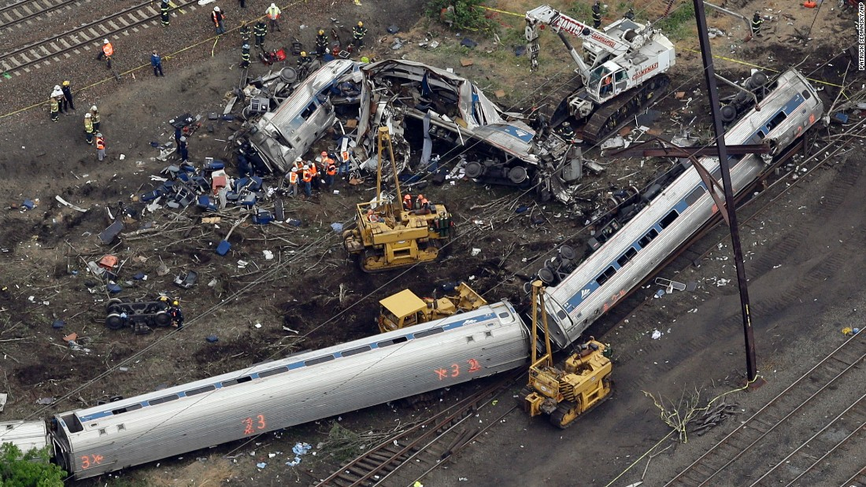
This month’s Amtrak disaster is just the tip of the iceberg. Patrick Semansky, AP.

The recent and entirely preventable Amtrak tragedy outside of Philadelphia did more than shatter trains and innocent lives. Amtrak’s inability to afford advanced train control technology laid bare the rot at the core of the country’s public infrastructure. While the need for improved high-speed rail in certain parts of the country should be obvious, America’s transit and infrastructure hollowness extends far beyond the much (and unfairly) maligned Amtrak. The crash was just one consequence of our refusal as a society to invest in critical shared needs, and is a harbinger of much worse things to come if we do not start making different choices.

On a recent weekend trip to New York City, I listened to friend after friend complain about the declining subway service on the MTA. Trains, they said, are slower and less reliable than they once were. The subway is the nerve center of New York City, without which the city would collapse into an un-navigable maze of traffic-clogged streets and human beings unable to get from point A to point B. New York features perhaps the greatest concentration of urban wealth in the history of civilization. It is America’s most famous and most important city, and home to more billionaires per square inch than any piece of real estate on the planet. So if the world’s richest city is incapable of keeping its own arteries clear, it might be a sign that something is deeply wrong with the country’s beating heart.

In the mid-20th century, U.S. infrastructure was the best in the world. In the 50s and 60s, the country was deliberately crisscrossed with state-of-the-art highways. While those highways contributed much to the destruction of cities and neighborhoods, at the time many of America’s most populous cities sported newer rapid transit systems with the potential for expansion. But those days are long past. Anyone who still believes that the United States has the best of anything has probably not spent much time abroad lately. Even middle-income countries generally have nicer infrastructure than the United States. Fly through the gleaming new airport in Kuala Lumpur and then try to grit your way through LAX or JFK. Ride the Japanese train system, and then try fighting your way onto an Amtrak or New Jersey Transit line at New York’s Penn Station. The comparisons are unflattering to say the least.

Even for Americans who live in one of the few cities with real subways, the idea of a quiet train arriving every two minutes – as they do in many European cities – would be dismissed as a socialist fantasy. The wealthiest and most prosperous cities in the United States have subway systems that are so old and inadequate that they would get laughed at in secondary cities around the globe. Boston, an unfathomably rich city filled with investment bankers, doctors and consultants, spent billions putting an interstate underground, but the city’s rapid transit system – the ‘T’ – features aging trains that crawl along in genuinely ancient tunnels at roughly the pace of a pushcart, and make excruciating noises that sound like a Transformer is being murdered on a chalkboard. The infrastructure of the T is such a disaster that the system effectively collapsed when Boston was hit with a Biblical wall of snow in February. One line still uses trains built in the 1940s. This is because despite being home to an obscene number of rich people in a city where rent is beyond the reach of even many middle class residents, Boston is somehow broke.

Putting a train underground is a technology that was discovered in the 19th century. These systems are expensive to build and operate but they are not exactly beyond the economic reach of one of the world’s richest countries. The idea that there simply is no money to do these things has become so deeply ingrained in the American psyche that we lose sight of how easy it seems to be for other societies to make different choices. Do you know what city recently opened a new subway line? Cairo – the capital of a country that has experienced two regime changes in four years and whose economy is such a flaming ruin that you can see the smoke from Dubai. You know who else just opened an underground? Algeria – a country that only recently emerged from a 10-year civil war that claimed 10% of the population. This ruined country with a GDP that is a tiny fraction of America’s somehow managed to build a new metro in the capital city of Algiers. It should also not surprise you to know that many of China’s growing cities sport rapid transit systems that make Chicago’s or San Francisco’s look like a toy train set from the 1950s, with dozens more lines under construction across the country at staggering costs.

In the United States, spending money on anything but building new roads is political poison, and the fiscal monomaniacs in the House GOP have even started balking at that. In 2010, New Jersey’s Republican Governor Chris Christie spiked plans for a new tunnel underneath the Hudson River connecting New Jersey to New York. The existing tunnels – the East River Tunnels – are ancient contraptions well past their 100th birthdays and are desperately in need of augmentation. Keep in mind that we are talking about tunnels bringing people from a very rich state onto a tiny island where condos routinely sell for $25 million apiece. The lack of adequate infrastructure through New York City ties up millions of commuters in needless traffic jams and rail delays, and helps ensure that countless Amtrak trains through the Northeast Corridor are delayed at least a few minutes.

Chris Christie was re-elected Governor of New Jersey in 2013 with 60.3% of the vote.

How is it possible that an obscenely wealthy and powerful country whose economy is growing at roughly 2% a year and whose per capita GDP is over $53,000 can be home to city after city and province after province that is flat broke and unable to perform routine maintenance on its existing architecture, pay for public goods like parks and libraries, or finance schools and universities? The answer is quite simple: we have decided as a society to spend money on other things, and perhaps more importantly, to allow private citizens to hoard colossal amounts of cash with absolutely no limits. We have decided that when structural economic forces hollow out once-great cities like Detroit, that we will hold them upside down like Repo Men and shake them until everything falls out – the remaining spare change, the art museums and libraries that once formed the city’s cultural backbone, the water service bills of hopelessly impoverished residents and then finally the people themselves. Because of course in a crisis cities and states should be treated like short sales and sold off to the nearest real estate developer. Because obviously the rule that says the country’s 400 richest people can collect more wealth than all 41 million African Americans combined was handed down by the gods of capitalism on scrolls made of dollar bills and must not be tinkered with. Because clearly the best way to run a functioning capitalist democracy is to pit your own underfunded provinces against one another in a ruthless game of Loot The Infrastructure.

Here is a short list of things they don’t come after the endless cycle of fake economic crises caused by our failure to properly tax and allocate wealth: sports stadiums and the back taxes of the teams that play in them, needless $34 million military bases in Afghanistan, joint strike fighter jets that cost $337 million each, redundant intelligence organizations that do the same work as other agencies, the salaries of the aspiring Randian plutocrats in Congress. We choose to finance these programs, while intentionally wrecking our world-renowned systems of public higher education, which are no longer public in any meaningful sense. We will seize the pensions of public workers and eliminate funding for the arts. We will close public beaches and starve public parks and nickel-and-dime citizens with predatory fines and fees. We will strip transit agencies down to their steel bones and blame them when something goes horribly wrong. We will watch our bridges collapse and our great cities flood and we will shrug our shoulders when children become the unwilling subjects of fiscal experiments perpetrated by investment bankers and clueless billionaires. We will wait longer for trains, and the trains will crash, and we will sit in debilitating traffic jams because there is no other way to get around. We will do all of this because we think we are broke even though we are not broke at all. In this one instance the poverty scolds are right: We have chosen to be poor.

We should probably get used to the unique poverty of dysfunctional infrastructure. Amtrak’s Northeast Corridor system alone needs at least $20 billion in upgrades, a figure that will never be seriously entertained by the glorified payday loan sharks currently running Congress. In fact the House GOP voted with its signature absence of class and basic decency to cut Amtrak funding the day after the crash. Yet Amtrak’s deficit hardly approaches the estimated $3.5 trillion in critical improvements needed across all of the country’s transit infrastructure. There is only one way to meet these challenges: by raising minimum wages, taxing investments and financial transactions, raising the burden on the wealthy, reallocating wasteful military spending to public projects and holding states to minimum standards of taxation and public works.

That would be a start at least. Or we can sit back and enjoy the fruits of our determination to turn what’s left of our shining city on a hill into a strip mine.

